# Chapter 5 Testing

Testing helps to find out the working process of the project as how well it operates. It also determines the objectives/requirements has been met or not. The system is being tested to check out its usability. Testing is done to ensure whether the system is defect free or not and to check whether the actual result match the expected result. It also helps to find out the bugs or any missing requirements from the system. Testing is important because software bugs are much expensive and dangerous as it causes life loss. There are various types of testing that helps to make the system error free. Some of them are;

## Blackbox testing:

Here testing is based on the requirements and functionality so the internal system is not considered most in this type of testing. It is also called the functional testing. It is used for validation.

## Unit testing:

An individual unit or group of inter related unit is tested here. For this testing all the program design and code knowledge is required so it mostly done by the programmers than the testers. In software design it is most essential as it focus on the smallest units.

## Whitebox testing

This testing is also known as Glass box testing and structural testing. It is based on the knowledge of the internal application code. This testing is used for verification.

For my project to check whether there are missing requirements or not and to check whether the system is defect free, I have done Blackbox testing and Unit testing.

Blackbox testing Result:

Admin/User Login

|  |  |  |  |  |  |
| --- | --- | --- | --- | --- | --- |
| Testcase | Expected Result | Actual Result | Pass/fail | Action | Conclusion |
| Login | User should get logged in by inserting their username and password | User get logged in successfully. | Pass | Not needed |  |
| Data validation for login | User should notify for invalid username and password | User get notified of invalid input while login | Pass | Not needed |  |
| Checking the valid username and password | users without having their identity in database cannot get to login in the system. | Users having incorrect/new account cannot get directly to logged in. | Pass | Not neeeded |  |
| Dashboard login check | Once the logged in is confirmed dashboard can be able to access. | Dashboard can be able to access only if login is valid. | Pass | Not needed |  |

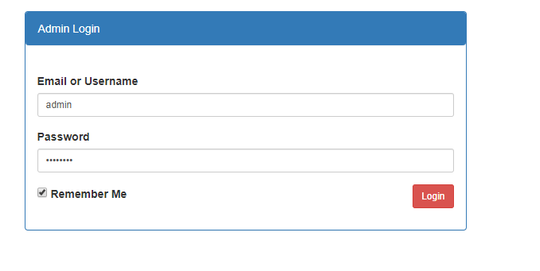

Figure 1 admin login

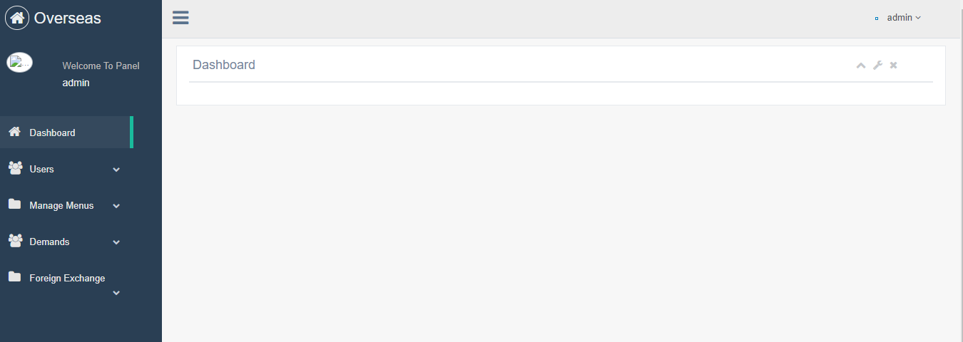

Figure 2 view of dashboard

Admin Login Validation

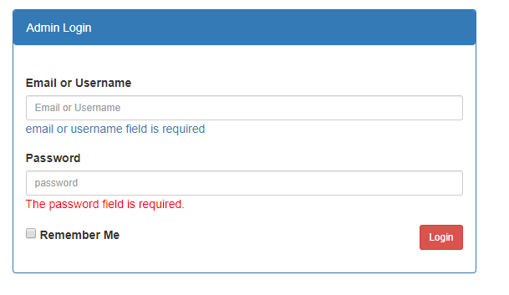

Figure 3 admin login validation without inserting username and password

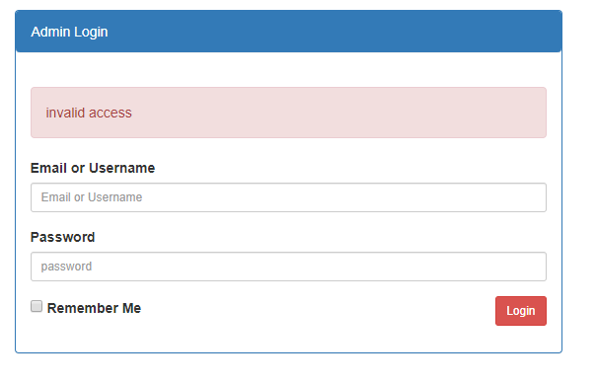

Figure 4 wrong username and password

User login

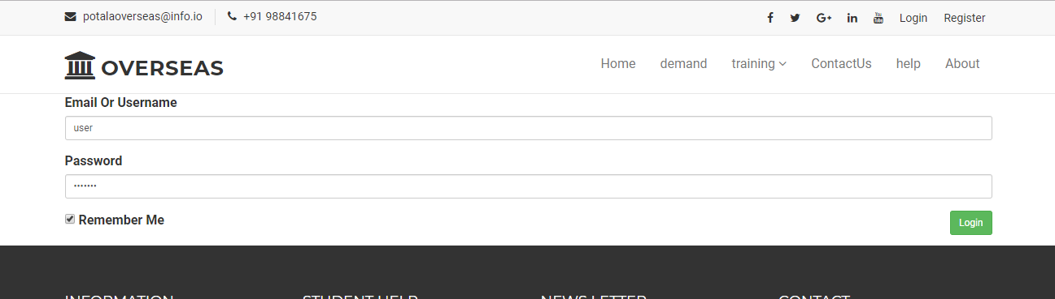

Figure 5 User login

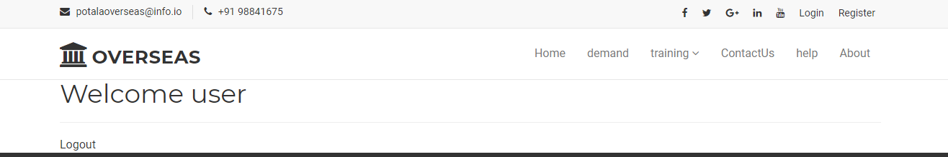

Figure 6 succesful login

User login Validation

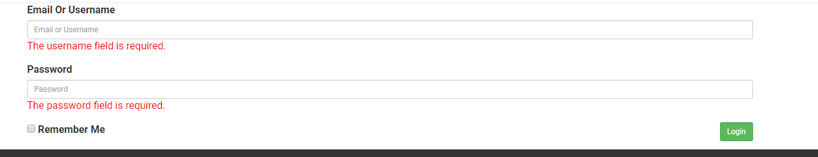

Figure 7 user login validation

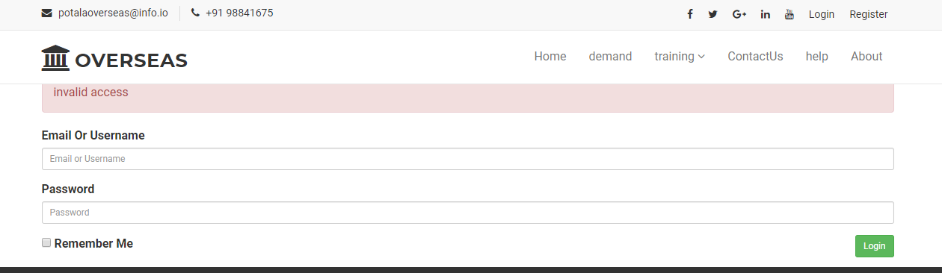

Figure 8 wrong username and password

Registration

|  |  |  |  |  |  |
| --- | --- | --- | --- | --- | --- |
| Registration | User to fill up their details so that they can get logged in to the system | User get registered successfully. | Pass | Not needed |  |

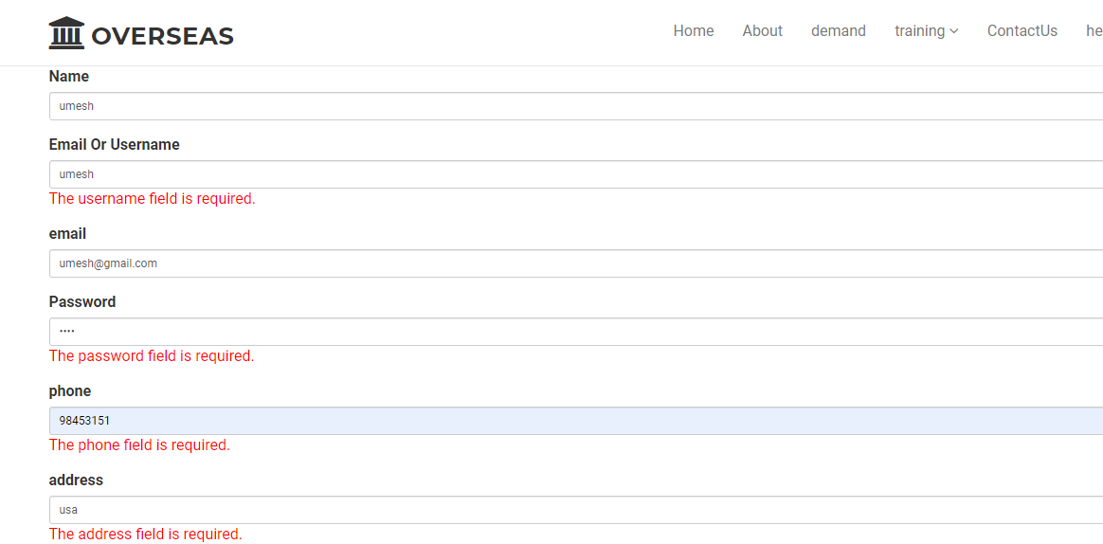

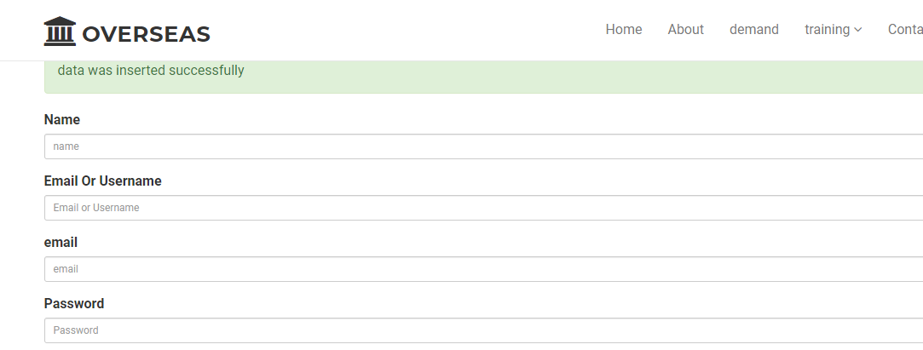

Add Contactus

|  |  |  |  |  |  |
| --- | --- | --- | --- | --- | --- |
| Add_contactUs | User can give suggestion/complaint against the system. | Users messages are added and updated. | Pass | Not needed |  |

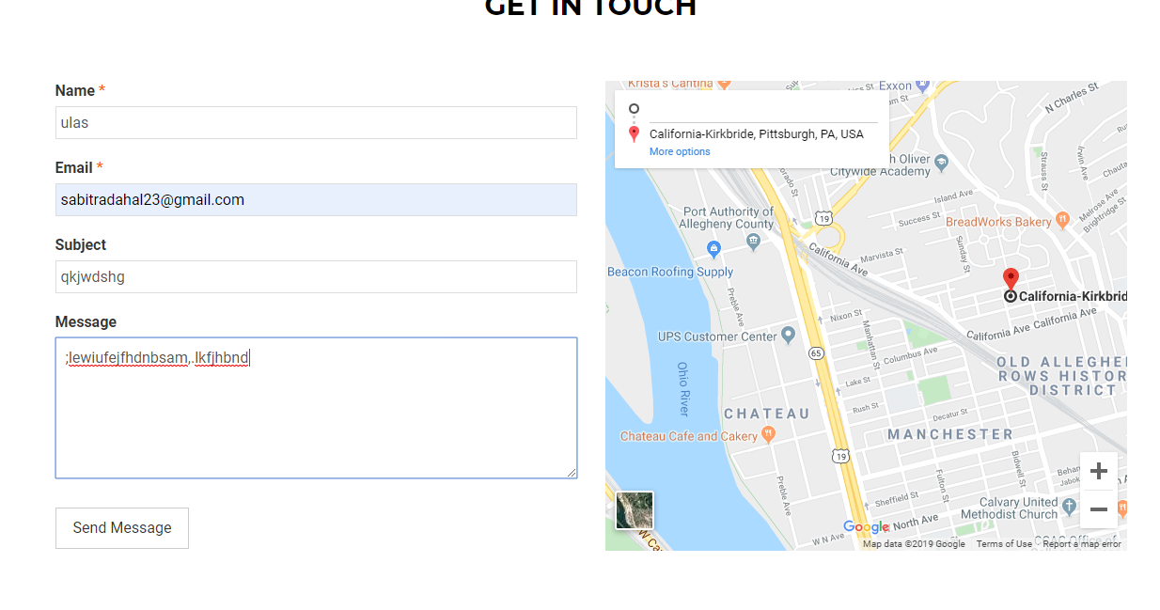

Figure 9add contoct

|  |  |  |  |  |  |
| --- | --- | --- | --- | --- | --- |
| Add-application | User can apply by inserting their all details including cv so that administrator can look forward for the process. | User get to apply for the new demand sending all their details. | Pass | Not needed |  |

Add application

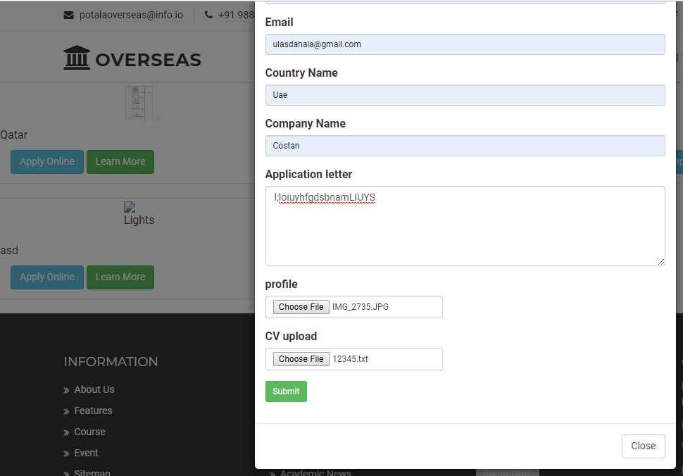

Figure 10 candidate can apply by inserting their personal details

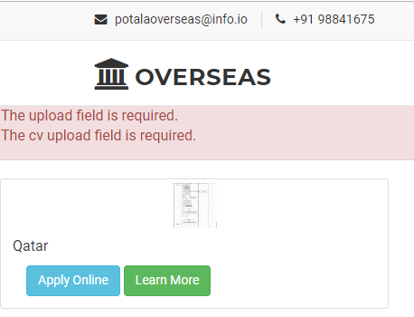

Figure 11 candidate must insert their profile and cv to apply

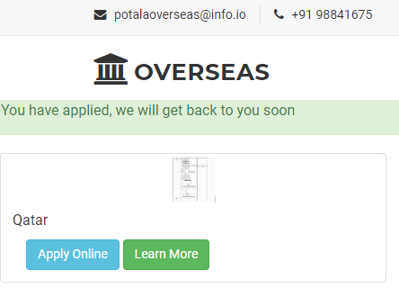

Figure 12 Notification on success applied

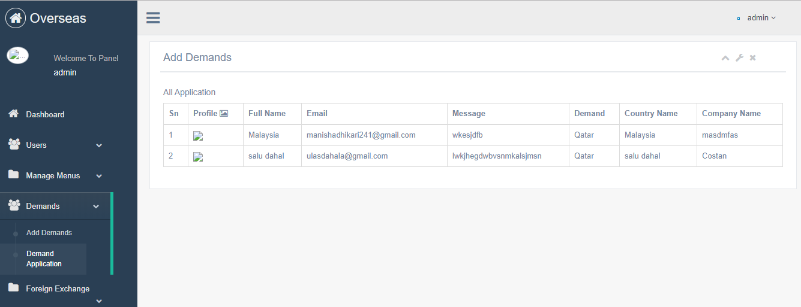

Figure 13 Record of applied candidate

Add menu

|  |  |  |  |  |  |
| --- | --- | --- | --- | --- | --- |
| Add menu | Admin should add menu for more information in the website | User can get to see all the updated pages information | Pass | Not needed |  |
| Edit menu | Later menu can be edited if any changes is essential. | Menu can be edited and updated as required. | Pass | Not needed |  |
| Delete menu | Menu can be deleted if it doesn’t have the importance. | Menu can be deleted from the website. | Pass | Not needed |  |

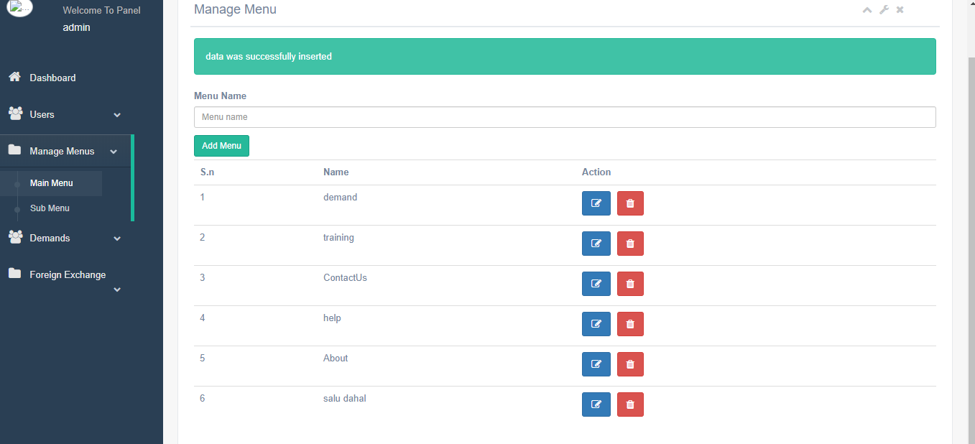  
Figure 14 add menu

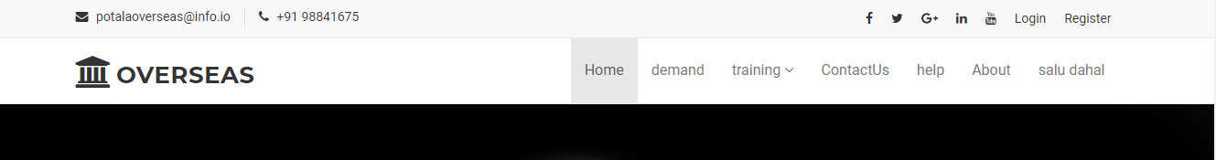

Figure 15 fronntend add menu

Edit/update menu

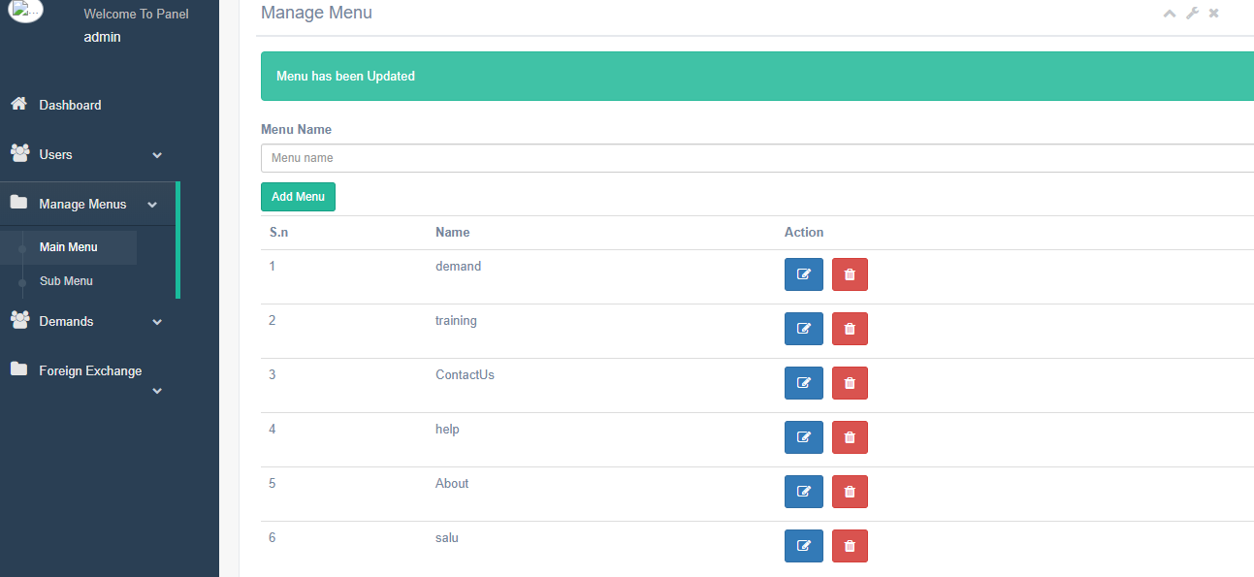

Figure 16

Delete menu

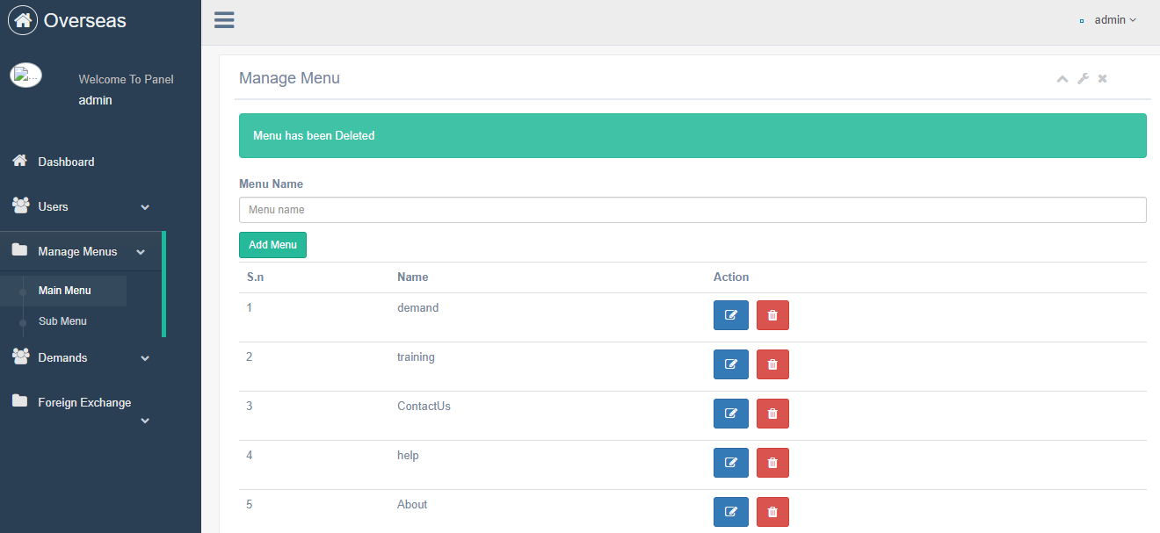

Figure 17

Add submenu

|  |  |  |  |  |  |
| --- | --- | --- | --- | --- | --- |
| Add submenu | For the dropdown of various related page submenu can be added | Required dropdown pages can be added | Pass | Not needed |  |
| Edit submenu | Submenu can be edited if required for more/less information | Pages dropdown can be edited and updated | Fail |  |  |
| Delete submenu | Submenu pages can be deleted if it has no importance | Submenu can be deleted | Pass | Not needed |  |

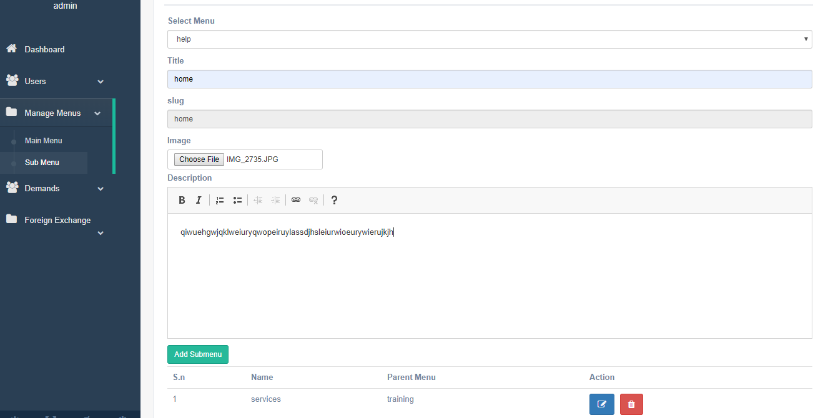

Figure

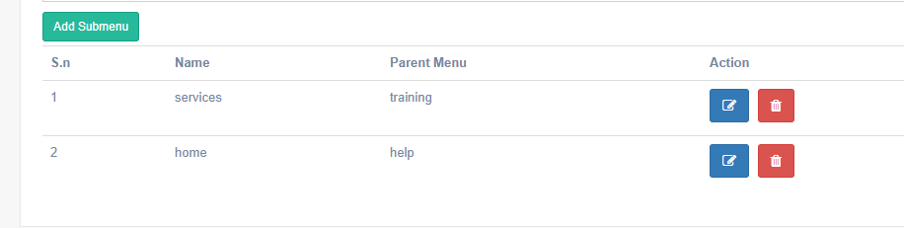

Figure

Edit/update submenu

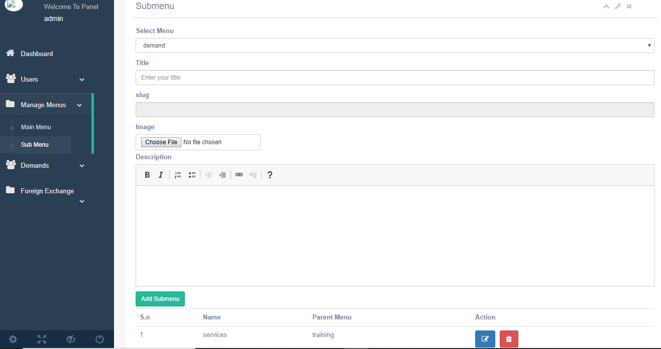

Figure

Delete submenu

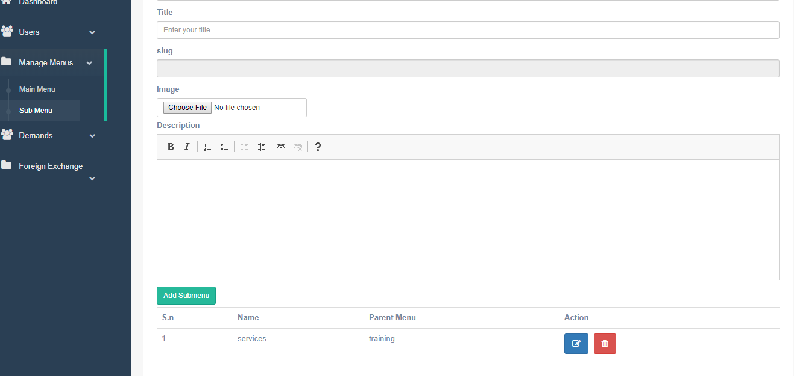

Figure

Add demand

|  |  |  |  |  |  |
| --- | --- | --- | --- | --- | --- |
| Add demand | Demand can be added for job category/required candidate | User can be able to see the demand inserted by the admin and choose the required demand | Pass | Not needed |  |
| Edit demand | Demand can be edited if there is any mistake | Demand can be edited and updated | Pass | Not needed |  |
| Delete demand | Demand can be deleting if candidate doesn’t require that job | Demand can be deleted | Pass | Not needed |  |
| View updated demand | Demand can be updated according to the candidate wish to work for and users can view all the updated demand | User can view all the essential updated demand | Pass | Not needed |  |

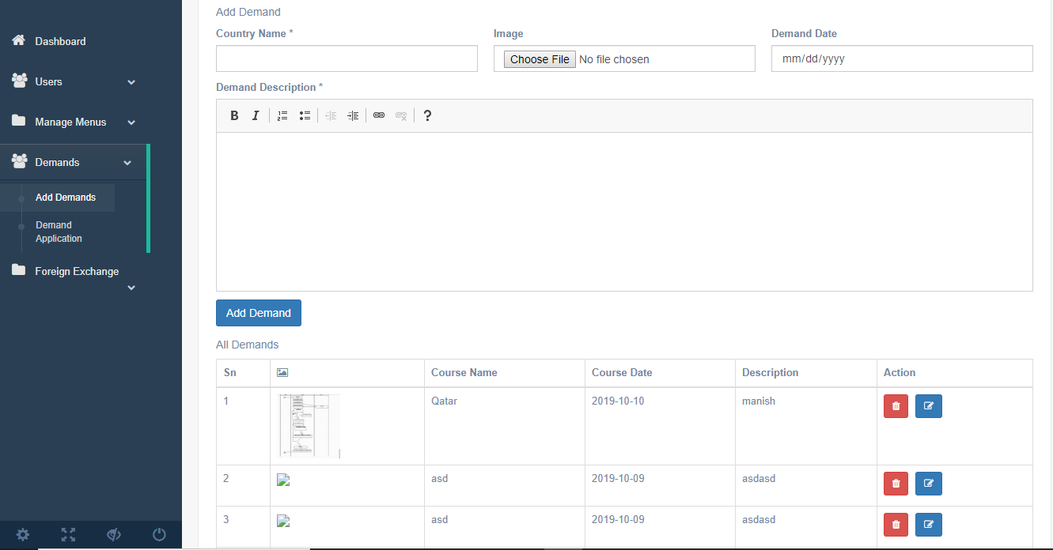

Figure 22

Edit Demand

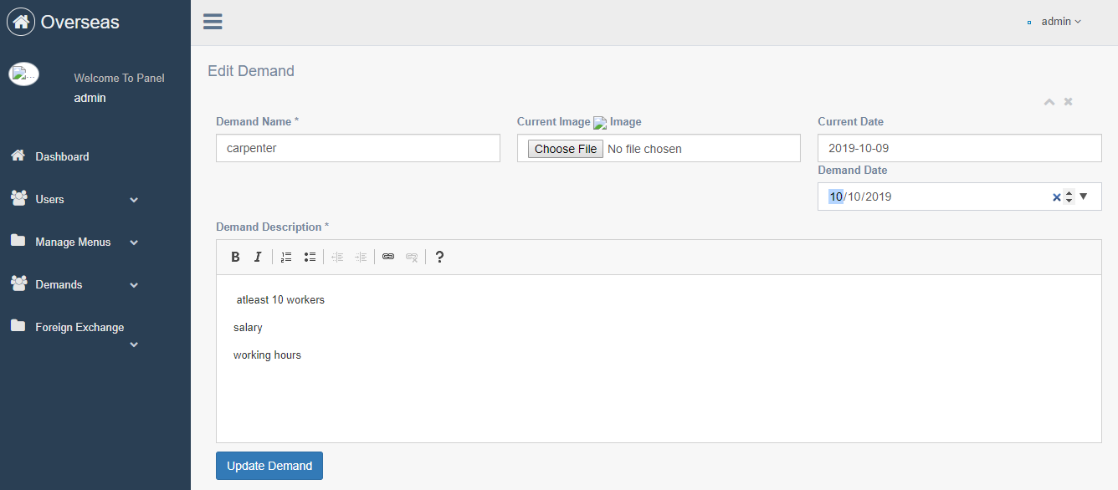

Figure 23

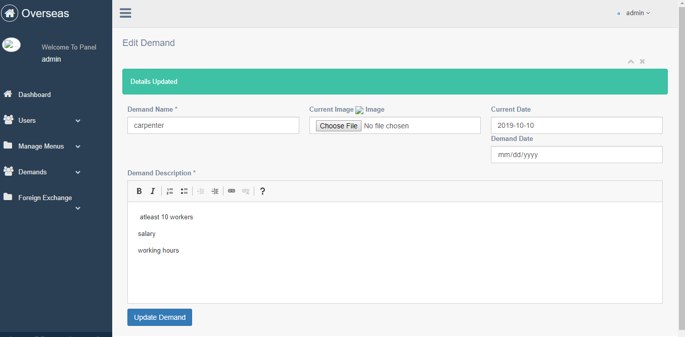

Figure 24

Delete Demand

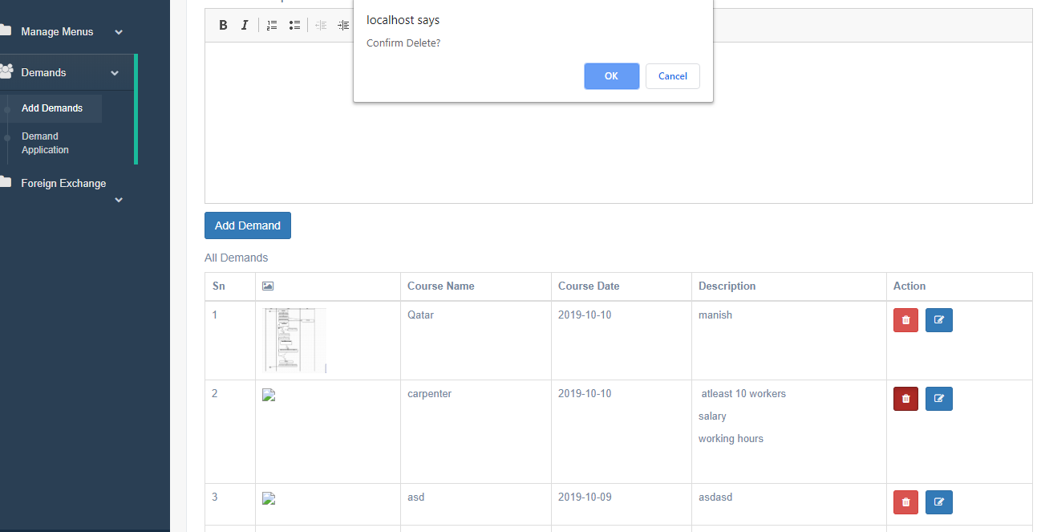

Figure 25

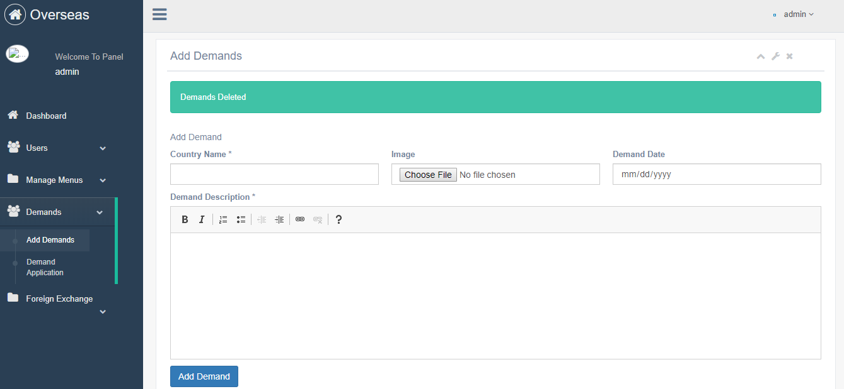

Figure 26

Update Currency

|  |  |  |  |  |  |
| --- | --- | --- | --- | --- | --- |
| Update currency | Currency can be edited if the rate is updated in market | Currency can be updated according to the market value | Pass | Not needed |  |
| View updated currency in frontend | Updated currency can be view by the users | Users can get to know the updated currency as per market value | Pass | Not needed |  |

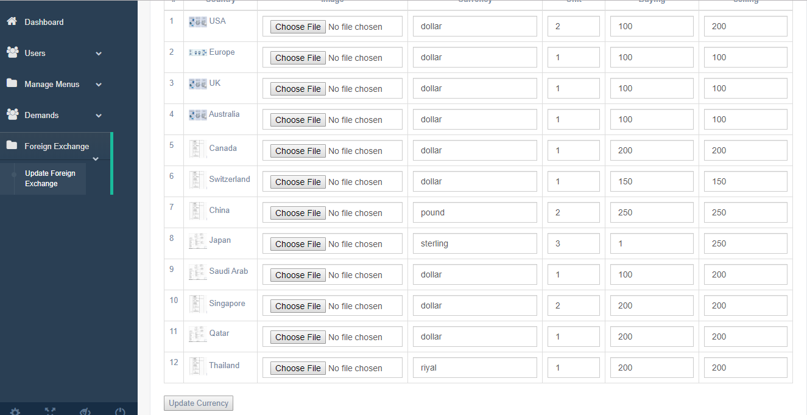

Figure 27

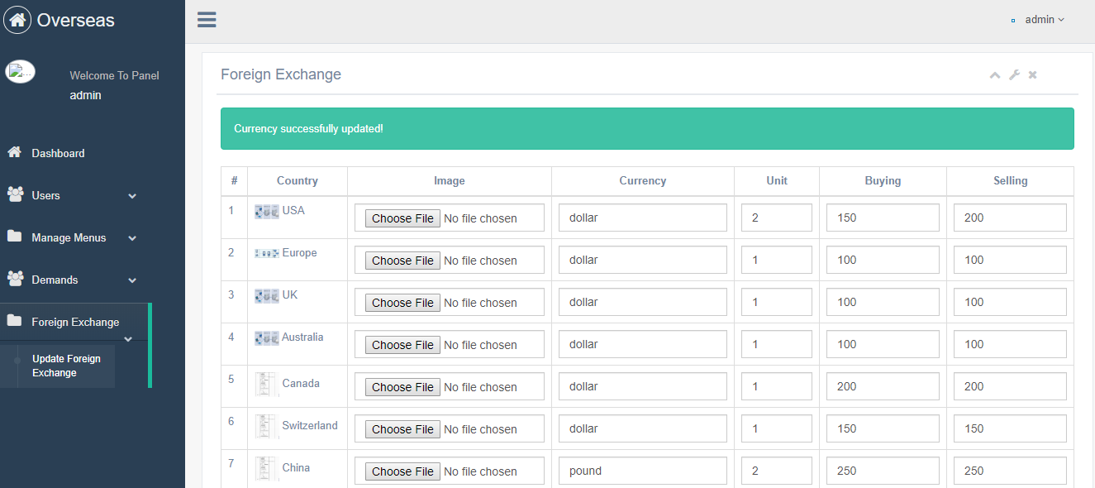

Figure 28

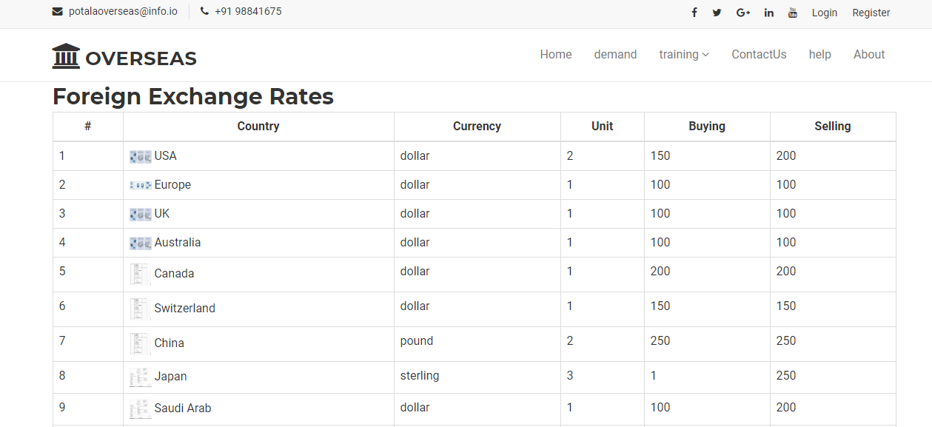

Figure 29

Admin logout

|  |  |  |  |  |  |
| --- | --- | --- | --- | --- | --- |
| logout | Users/admin can get out of the system by logging out their account. | User/admin can get logged out from the website to keep their details personal. | Pass | Not needed |  |

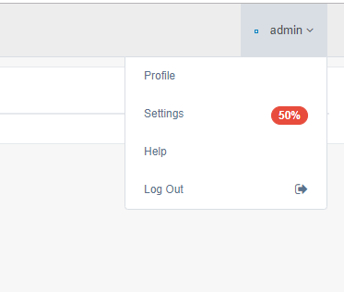

Figure 30

Help-users:

|  |  |  |  |  |  |
| --- | --- | --- | --- | --- | --- |
| Add_ help users | For any sort of help relating to system or any job-related user can fill the form and get help. | User ca get services related to their job enquiry | Pass | Not needed |  |





Add update delete admin

|  |  |  |  |  |  |
| --- | --- | --- | --- | --- | --- |
| Add admin/users | Multiple user can get logged in. | Admin and super admin are assigned as here super admin authority can be able to use the viewable users’ pages and can manage everything. | Pass | Not needed |  |
| Edit/Update admin | Super admin can update the details as admin cannot get access the page | Having the super admin authority can check the pages and can update the details | Pass | Not needed |  |
| Delete admin | Super admin can delete the details | Admin can be deleted from the dashboard. | Pass | Not needed |  |

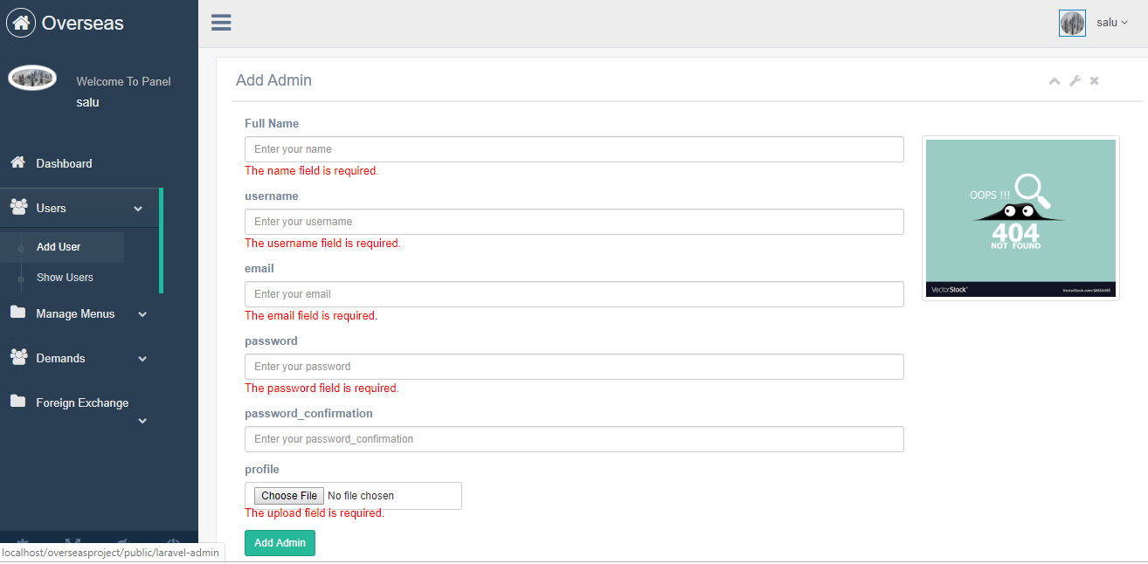

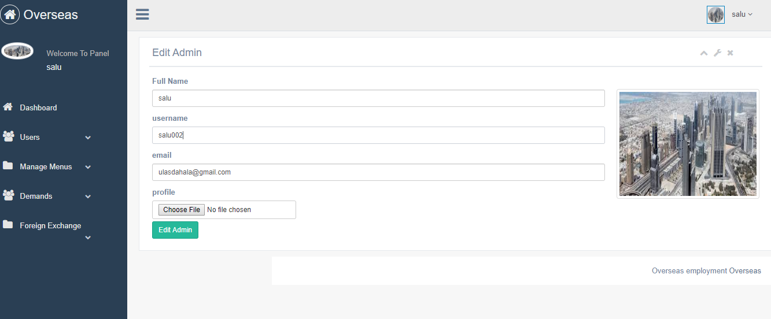

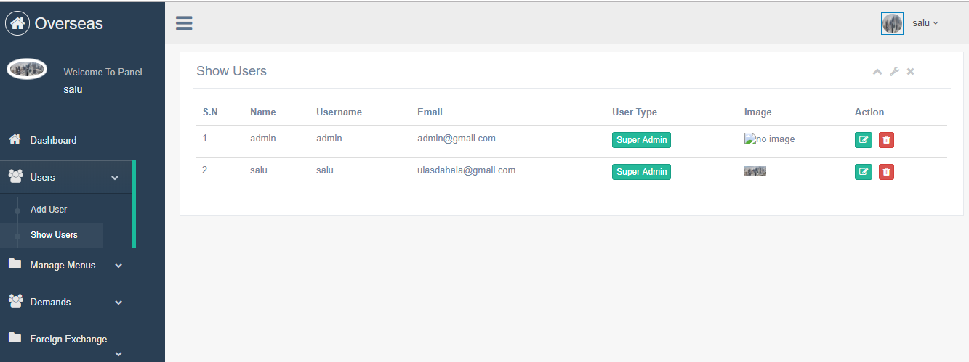

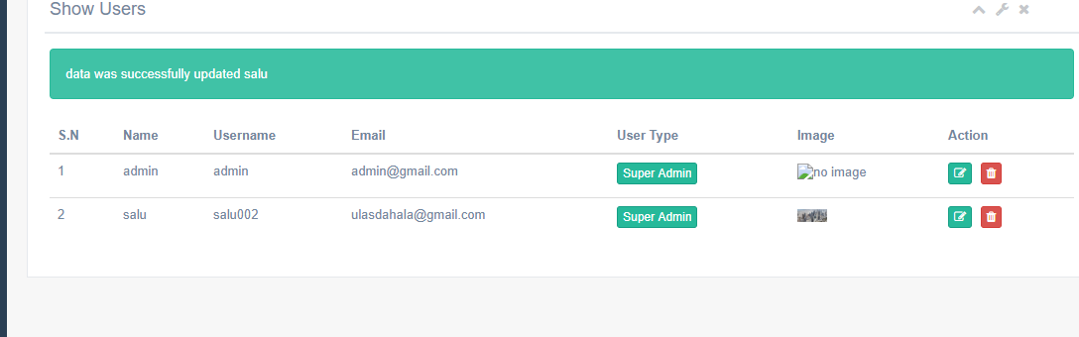

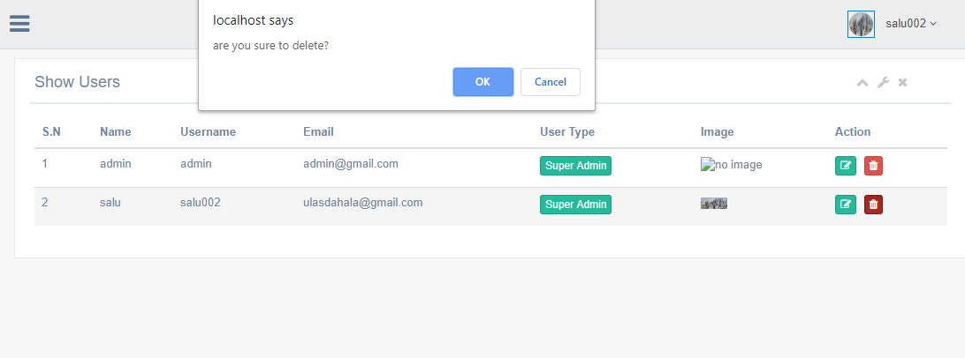

## Unit testing:

Test1

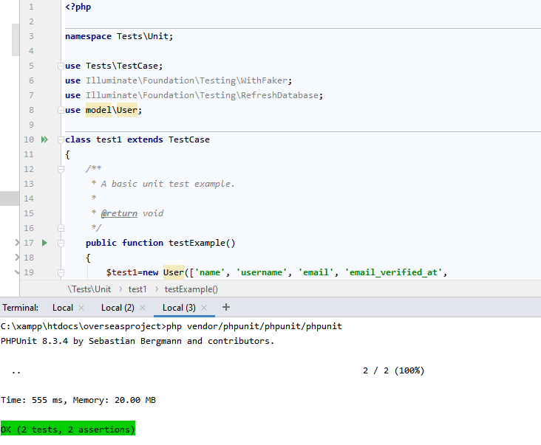

Figure 31

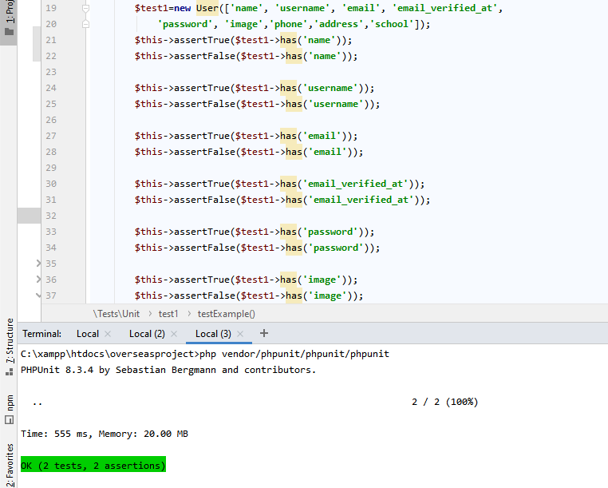

Figure 32

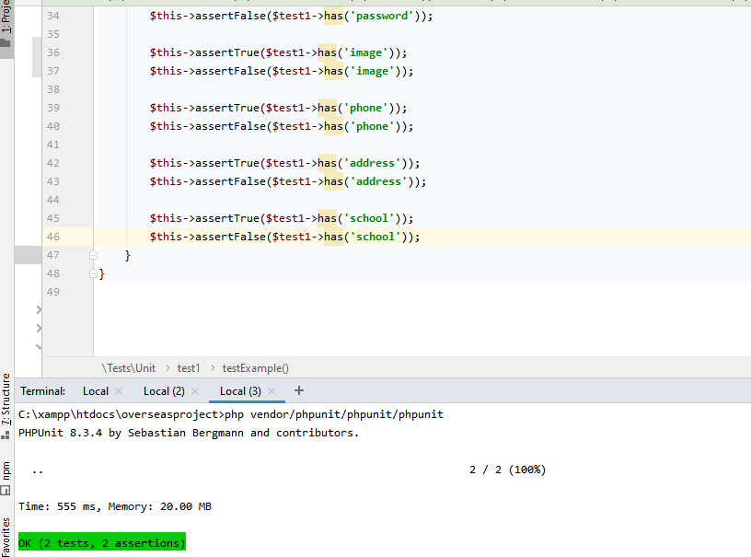

Figure 33

User test

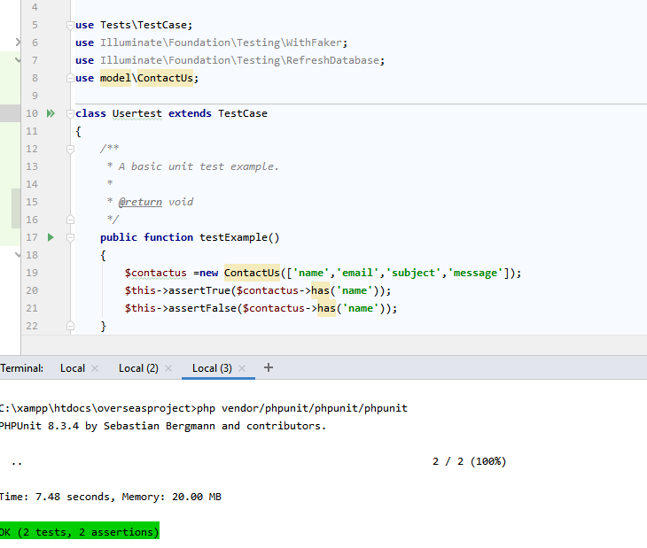

Figure 34

Admin test

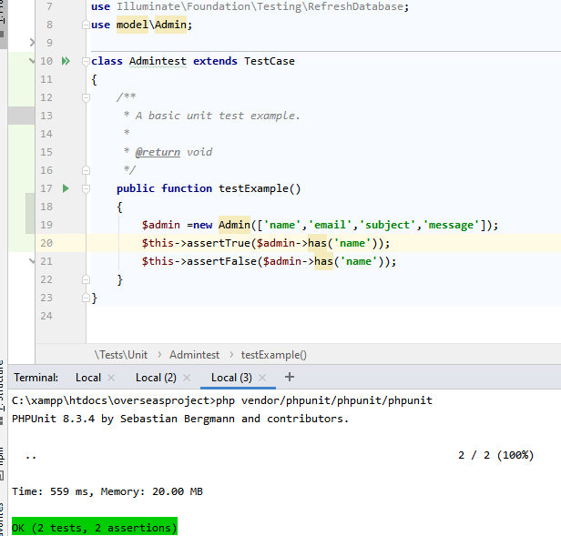

Figure 35

Application Test

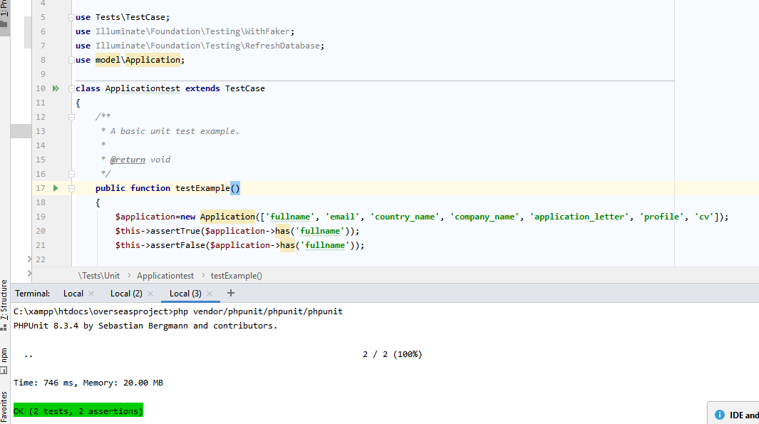

Figure 36

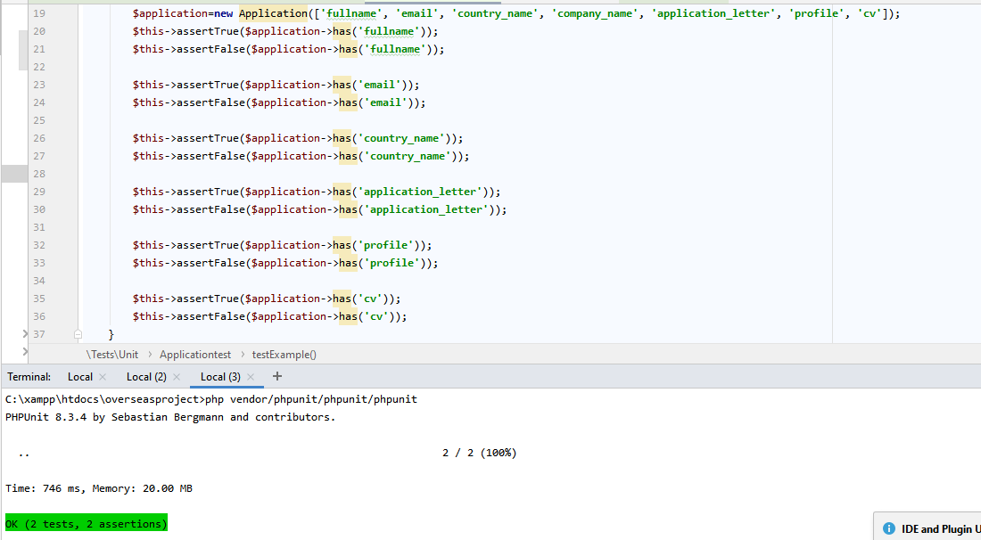

Figure 37

Demand Test

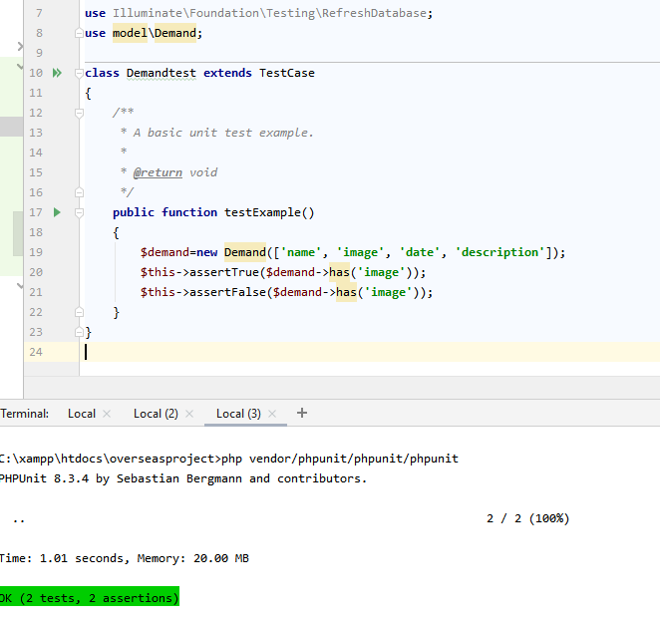

Figure 38

Menu test

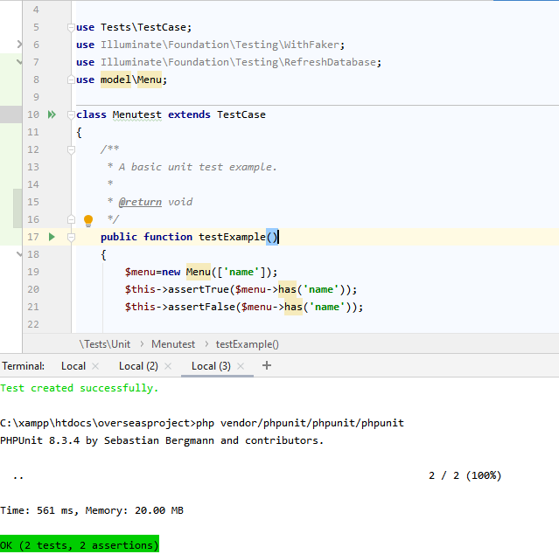

Figure 39

Submenu test

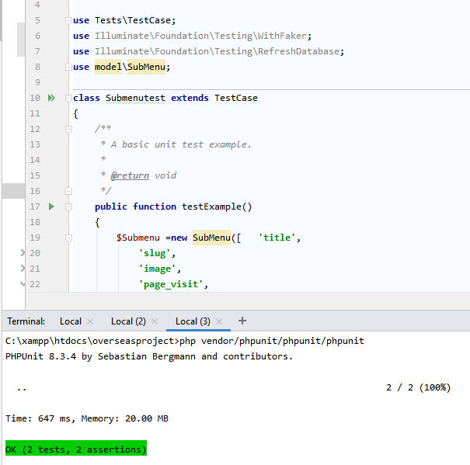

Figure 40

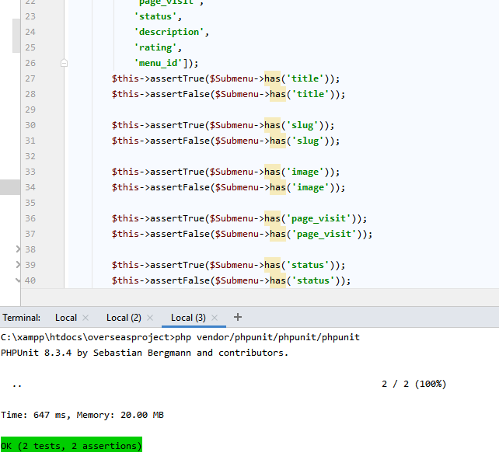

Figure 41

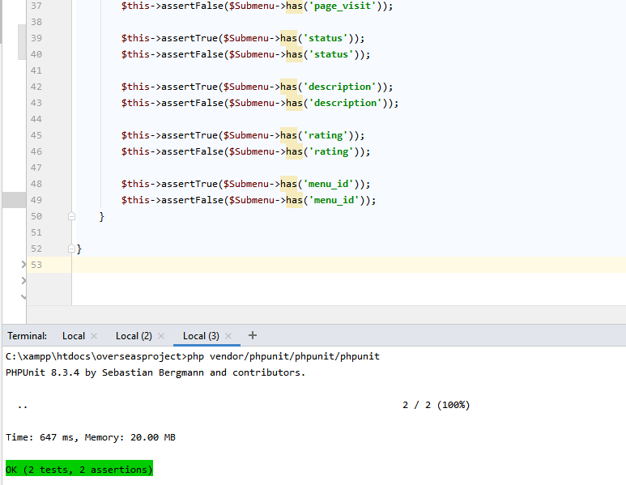

Figure 42

Forex test

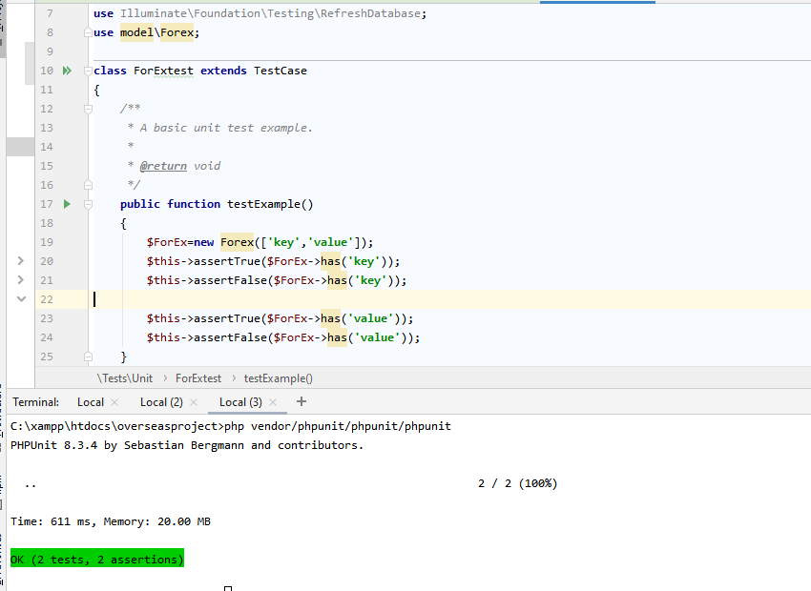

Figure 43